Thomas Zhu Work/Project Samples
Power BI:
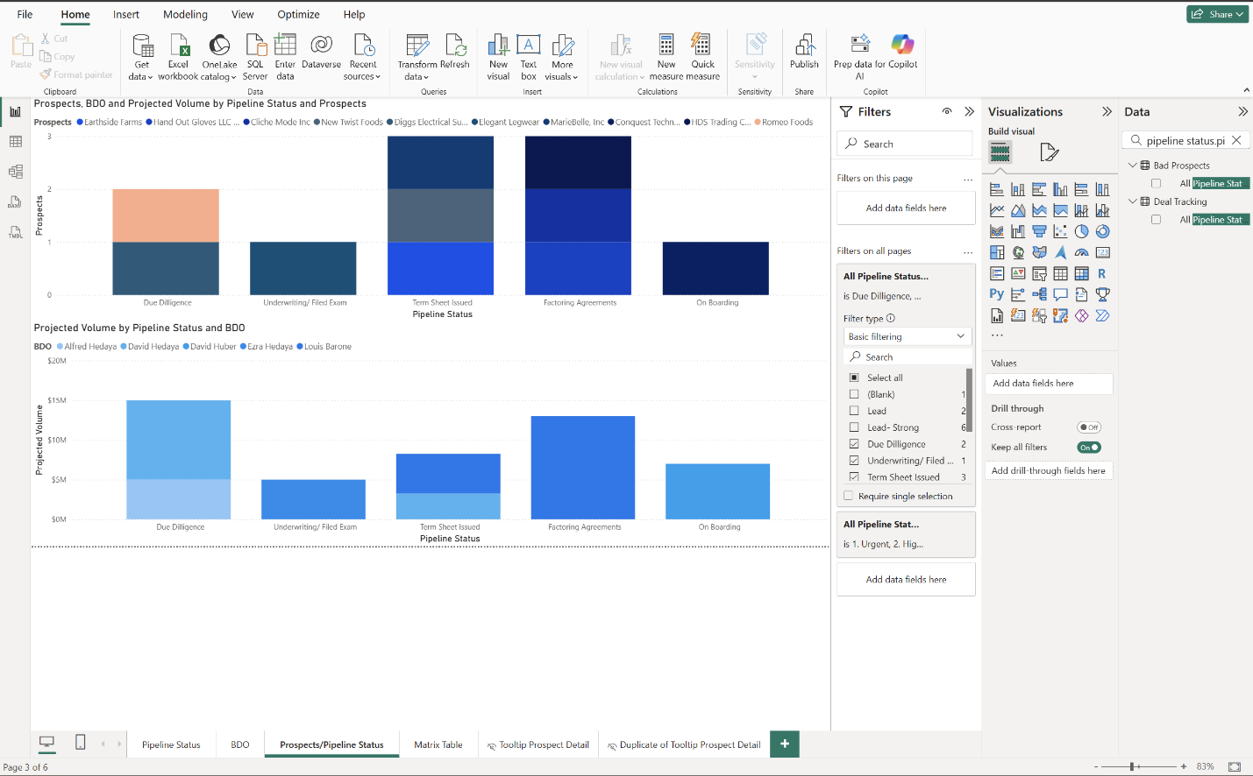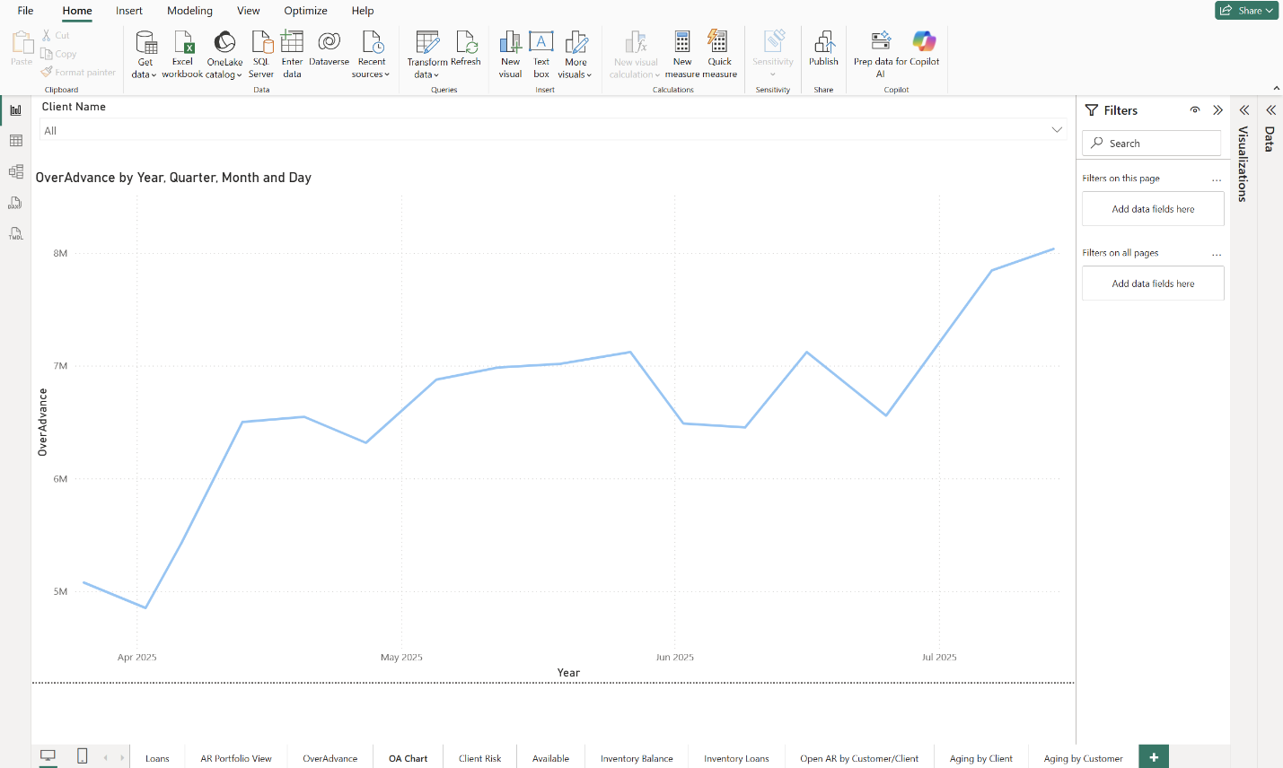
I worked on two Power BI projects during my internship at The Hedaya Capital Group: portfolio and business development. I was able to from scratch, set up the data linkages from a variety of difference sources. Whether it was daily emails coming in, excels, SharePoint lists, I was able to use power query to clean the data and make sure it is consistent everyday with the refreshing and accurate. I was able to develop custom tooltips using tables to show information that cannot be shown with normal tooltips or drag and drop. I learned to create custom DAXs to create calculations and time dimension tables.
New York University Data Analytics Project:
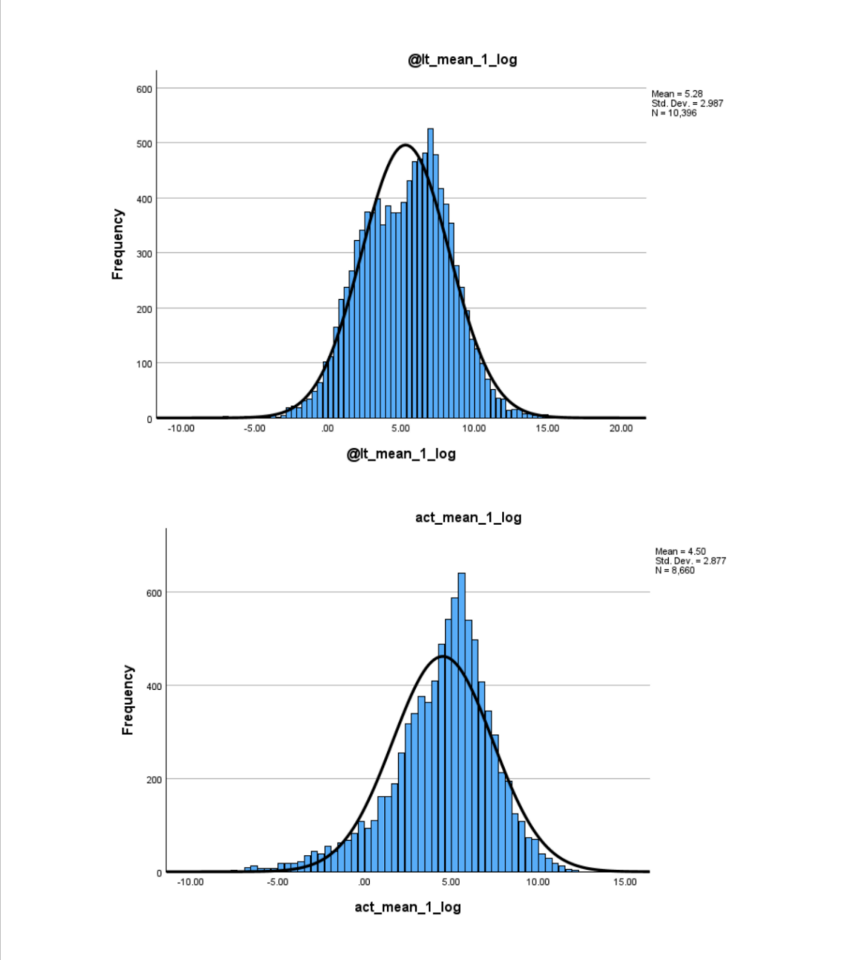
At New York University’s Business Analytics class, I worked on a project to estimate a company’s litigation chances by exploring which variables would make the predictive model more accurate. To do this we collected public stock data and then took all the variables and normally distributed them for analysis. We cleaned the data, prepared it and trial and error using different statistical methods like STEPWISE. We worked on the project in SPSS, and I can confidently say I am now very versed in SPSS.

IQVIA Excel:
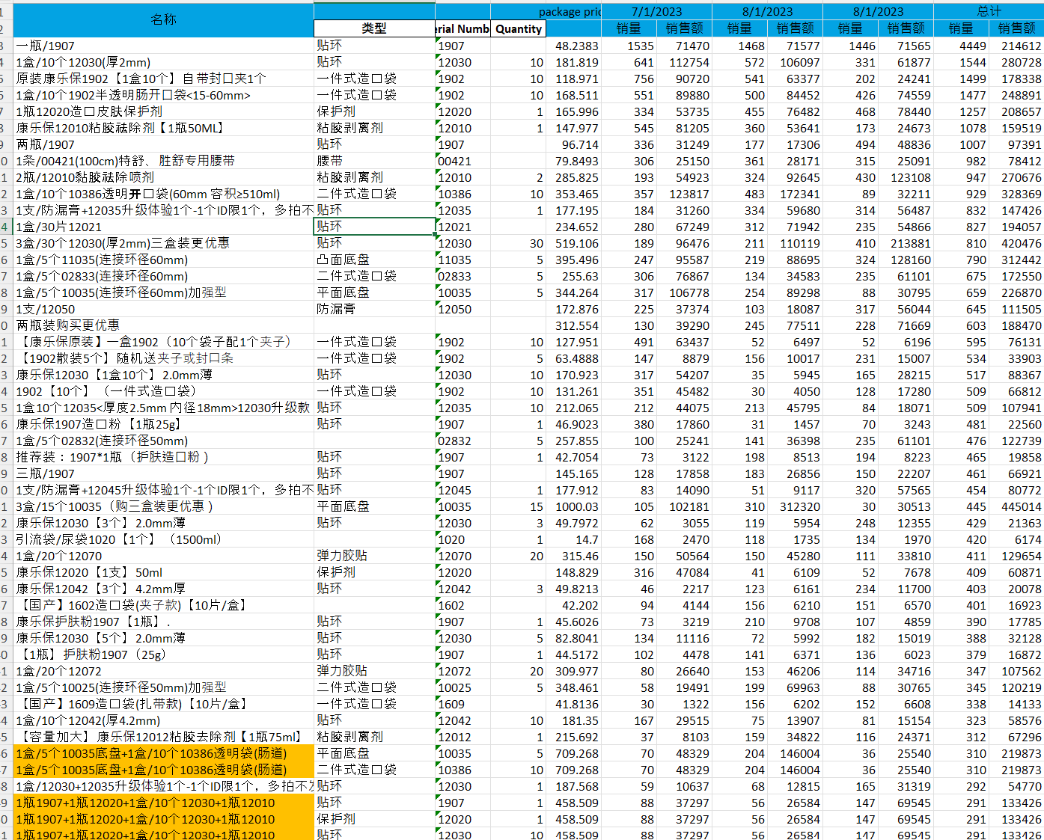
At IQVIA I worked a lot in Excel to develop my skills. I was using pivot tables, XLOOKUP, IFS, and various other Excel functions to conduct data cleaning and analysis. One project I worked on was using retail data for a client’s ostomy care product offering on major ecommerce websites to analyze trends. To do this we cleaned the data, and then conducted SKU breakdown analysis.

